**KPI Of the Project**

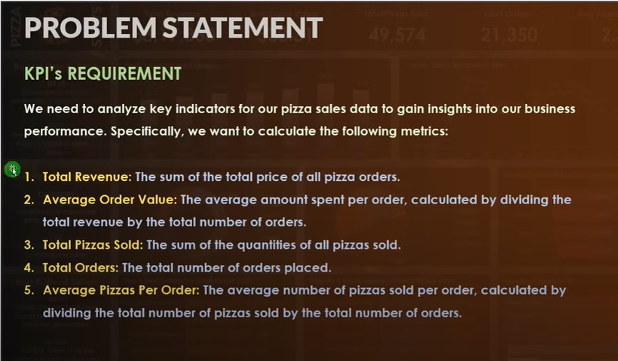

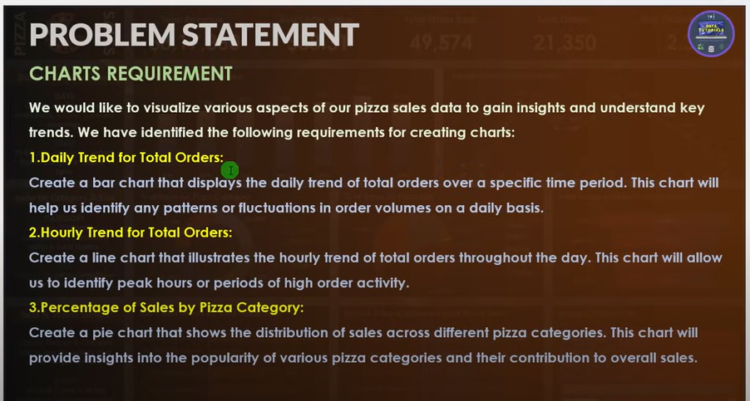

**Pizza Sales Queries**

A.KPI:

1.Total Revenue:

SELECT SUM(total_price) AS 'Total Revenue' FROM pizza_sales;

2.Average Order Value:

SELECT SUM(total_price)/COUNT(DISTINCT order_id) AS 'AVG Order Value' FROM pizza_sales;

3.Total Pizza Sold:

SELECT SUM(quantity) AS 'Total Pizza Sold' FROM pizza_sales;

4.Total Order:

SELECT Count(DISTINCT order_id) AS 'Total Orders' FROM pizza_sales;

5.AVG Pizzas Per Order:

SELECT CAST(CAST(SUM(quantity) AS DECIMAL(10,2)) / CAST(Count(DISTINCT order_id) AS DECIMAL(10,2)) AS DECIMAL(10,2))

AS 'AVG Pizzas Per Order' FROM pizza_sales;

B.KPI:

1.Daily Trend For Total Orders:

SELECT DATENAME(DW, order_date) AS order_day, COUNT(DISTINCT order_id) AS Total_orders

FROM pizza_sales

GROUP BY DATENAME(DW, order_date);

2.Monthly Trend For Total Orders:

SELECT DATENAME(MM, order_date) AS order_month, COUNT(DISTINCT order_id) AS Total_orders

FROM pizza_sales

GROUP BY DATENAME(MM, order_date);

3.Percentage of sales by pizza category:

SELECT pizza_category,SUM(total_price) AS Sales, SUM(total_price) * 100 / (SELECT SUM(total_price) FROM pizza_sales WHERE DATEPART(quarter, order_date) = 1) AS Percentage_per_category

FROM pizza_sales

WHERE DATEPART(quarter, order_date) = 1

GROUP BY pizza_category;

Note: In this query I use filter in first quarter in the year.

4.Percentage of sales per pizza size:

SELECT pizza_size,SUM(total_price) AS Sales, CAST(SUM(total_price) * 100 / (SELECT SUM(total_price) FROM pizza_sales) AS DECIMAL(10,2)) AS Percentage_per_Pizza_size

FROM pizza_sales

GROUP BY pizza_size

ORDER BY Percentage_per_Pizza_size DESC;

5.Total pizza sold per category:

SELECT pizza_category, SUM(quantity) AS Total_pizza

FROM pizza_sales

GROUP BY pizza_category

ORDER BY Total_pizza DESC;

6.Top 5 Best Sellers by Total Pizzas Sold:

SELECT TOP(5) pizza_name

FROM pizza_sales

GROUP BY pizza_name

ORDER BY SUM(quantity) DESC;

7.Botton 5 Worst Sellers by Total Pizzas Sold:

SELECT TOP(5) pizza_name

FROM pizza_sales

GROUP BY pizza_name

ORDER BY SUM(quantity) ASC;

